Bash Scripting Task | 15/10/2026

1: Simple bash scripting with “echo hello world”
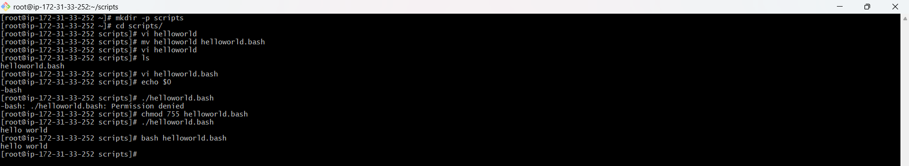
2: Executing bash file from absolute path
3: Executing bash file from relative path
4: Basic bash scripting with some basic commands
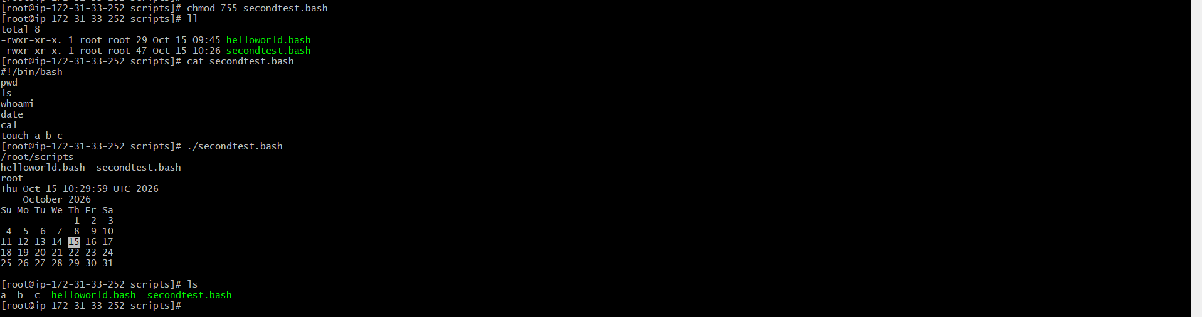
5: Bash scripting for some admin tasks
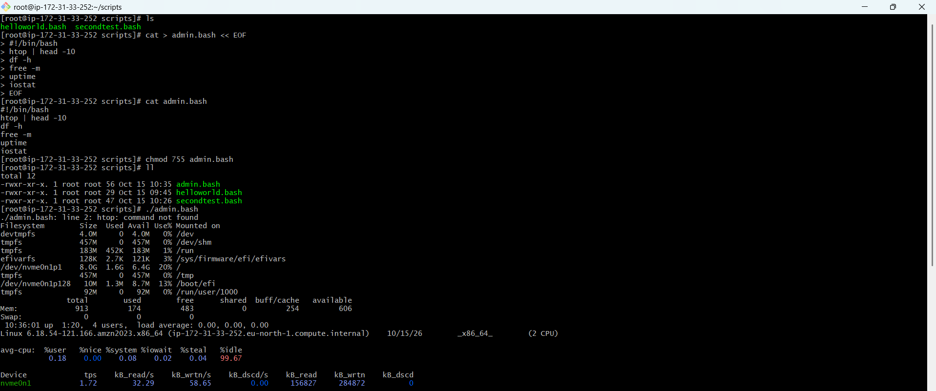
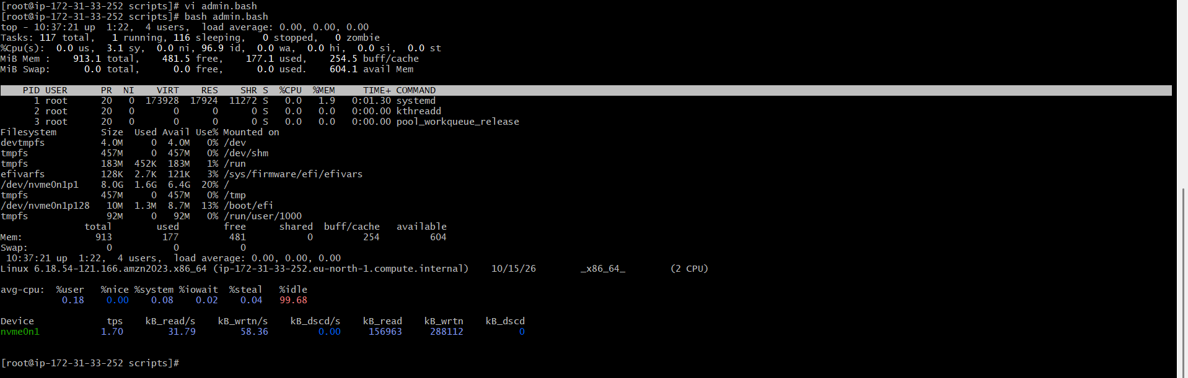
6: Basic bash scripting with variables
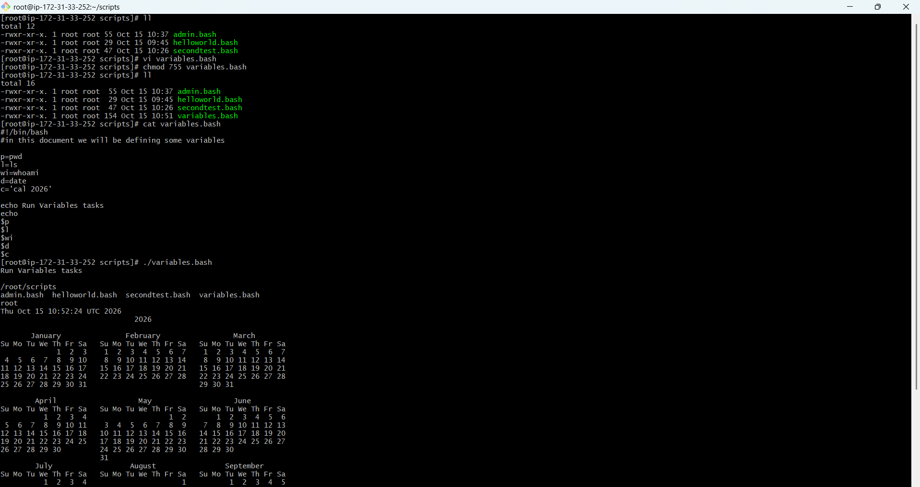
7: Input/Output bash scripting
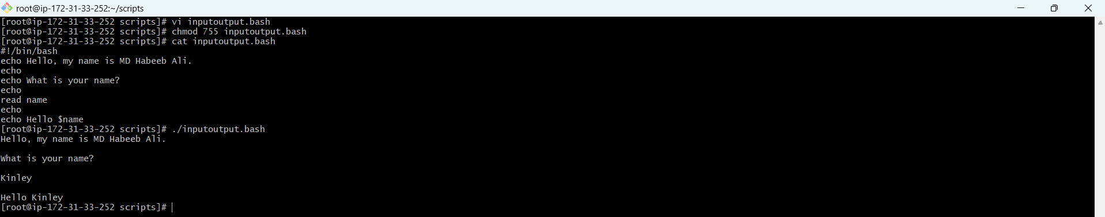
8: Input/Output bash scripting with variables
